Before starting, print both Payable and Receivable reports. A/P and A/R side need to be done at the same time to keep everything clear.

When entering an invoice for a contra, the invoices must be billed to a clearing account (1160-INT).

**Adjustments**

In Adjustments tab

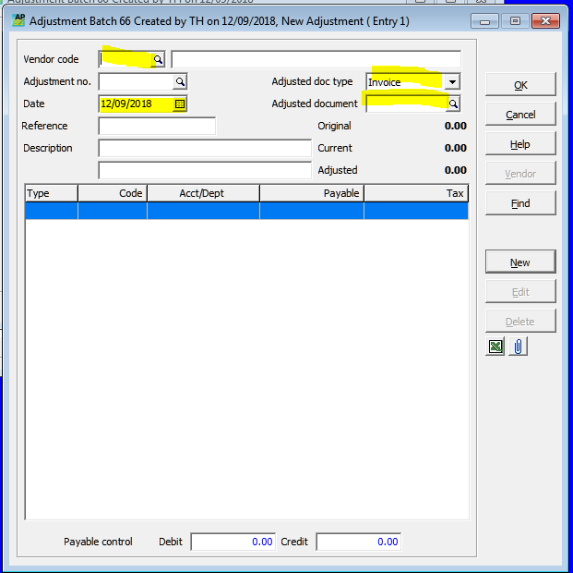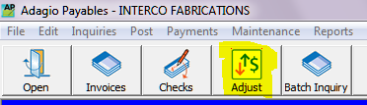

All invoices need to be adjusted individually.

In Adjusted Document, enter the invoice you are adjusting.

Change the date to be the first of the month not the date of the invoices.

Adjust from the same clearing account as the invoices (1160-INT)

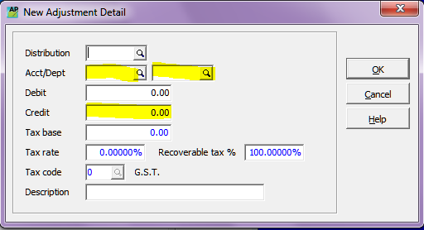Check the totals match before posting.

Make sure both A/R and A/P file have copies of the report and the adjustment listing. Write on the listing why you did the adjustment.